Serena Lee

2/23/22

SSW 345

*“I pledge my honor that I have abided by the Stevens Honor System”* - Serena Lee

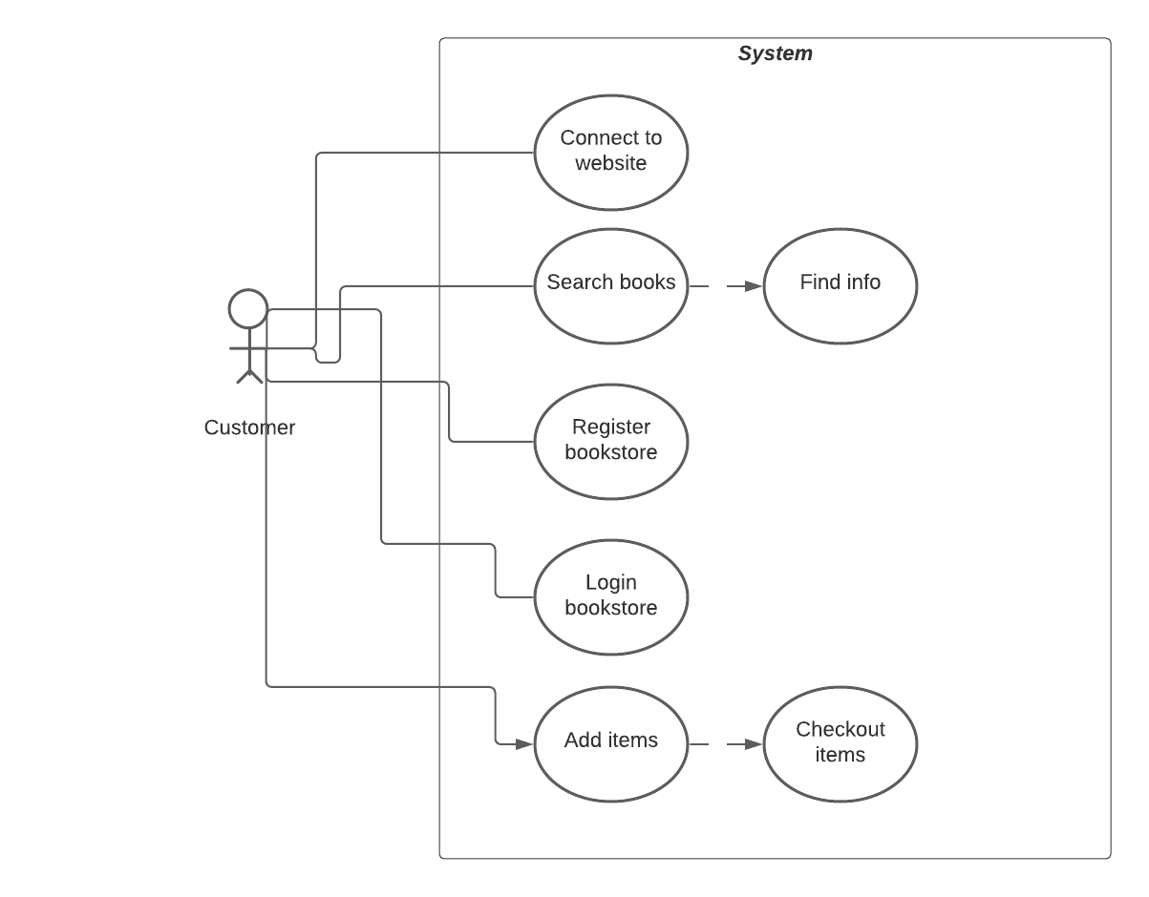

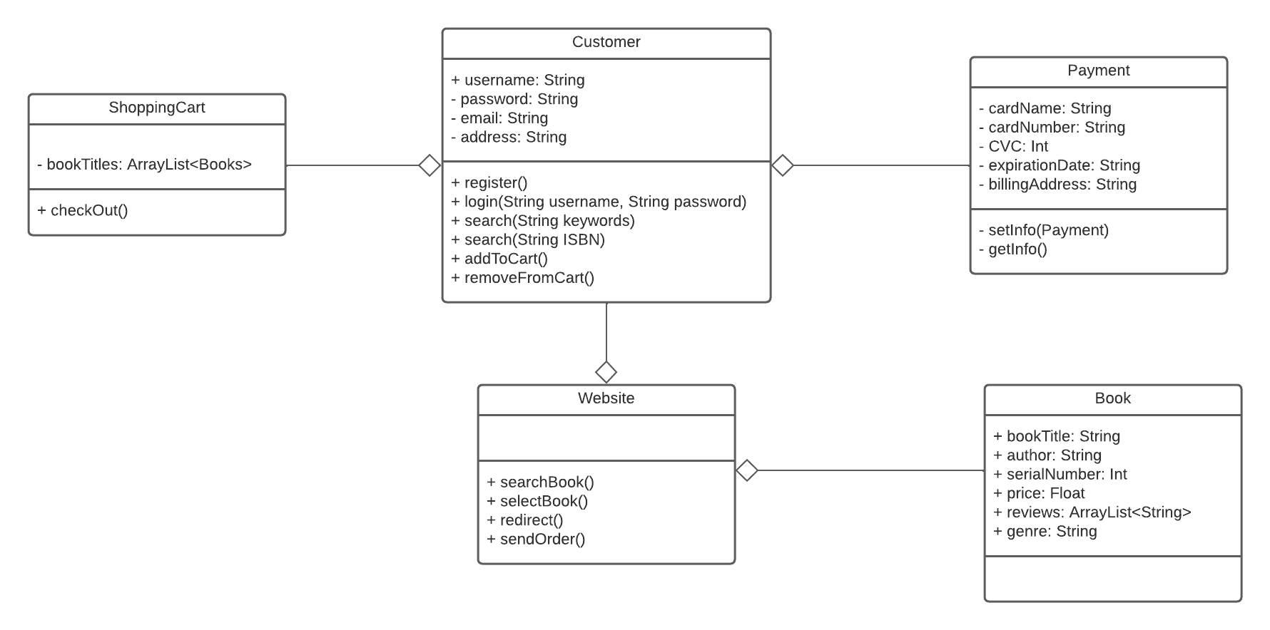

I based my class diagram on the basic functions of an eBookstore, such as Amazon. Most online purchasing sites follow the same format, login/register, select item(s), add to cart, checkout, and payment. The main center of this diagram is the customer because all the actions are decided by the customer. The customer has to register or log in to their account and from there, they can add books to their cart or remove them. Once the customers log in, they can browse the website for books and search for them by title, author, serial number, price, reviews, and genre. If the customer decides to purchase the books they have added to their cart, they will go to the payment section and put in their card information: card name, card number, CVC, expiration date, and billing address. This is a basic process for an online bookstore.

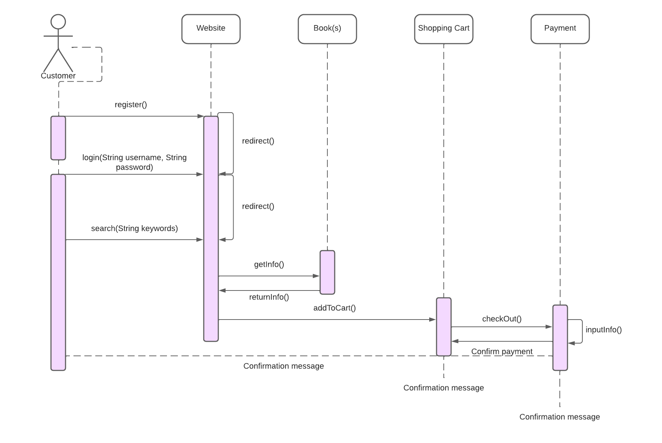

Very similar to the class diagram above, this sequence diagram represents a variation of the eBookstore process. The customer can register with the website if they have not, which will redirect them to the login page, the user will bypass this step if they already have registered with the website. The customer can search for books regardless of the status of their registration which is why it is directly connected to the website. Once at the website, they can get the information about the book they searched. Also from the website, they can add the book to their cart, and from there they can checkout and buy the book(s), and fill in their payment information. Once this is all completed, they will receive a confirmation email at each stage they went through.